A. Photosynthesis
- Write down the word equation for photosynthesis.
- Copy and complete this table
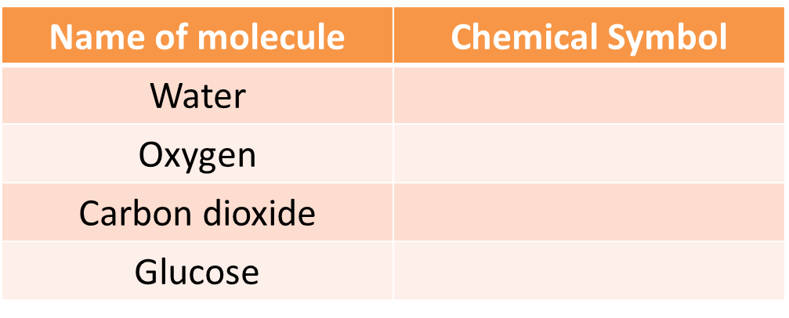

- Photosynthesis is affected by limiting factors. What is meant by the term ‘limiting factor’?
- Name the raw materials needed by a plant for photosynthesis?
- Name the green pigment present in plant cells.
- What is the role of this green pigment?
- For the graphs below - identify what the limiting factor(s) might be in the experiments.
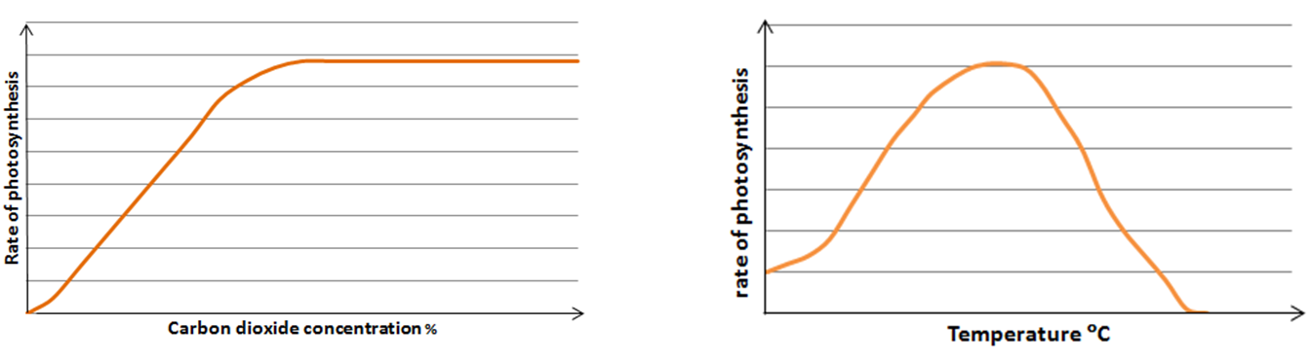
- Sketch a line onto Graph A showing what might occur if the experiment was repeated at a lower light intensity.
- List three ways commercial farmers improve the environmental conditions to maximise photosynthesis and ensure they make a profit.
- How is the glucose produced by photosynthesis used in plants?

Higher tier questions
- HT Calculate the light intensity for the following student data.
Use the formula: Light Intensity = 1/distance²
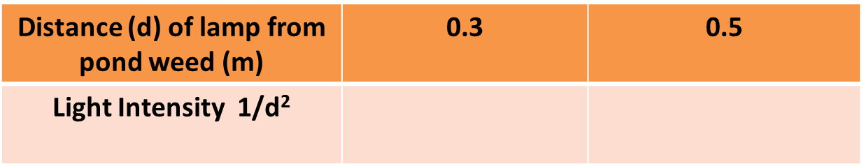
- Look at the graph.
  - What is the limiting factor at A?
  - What might the limiting factor(s) be at point B?
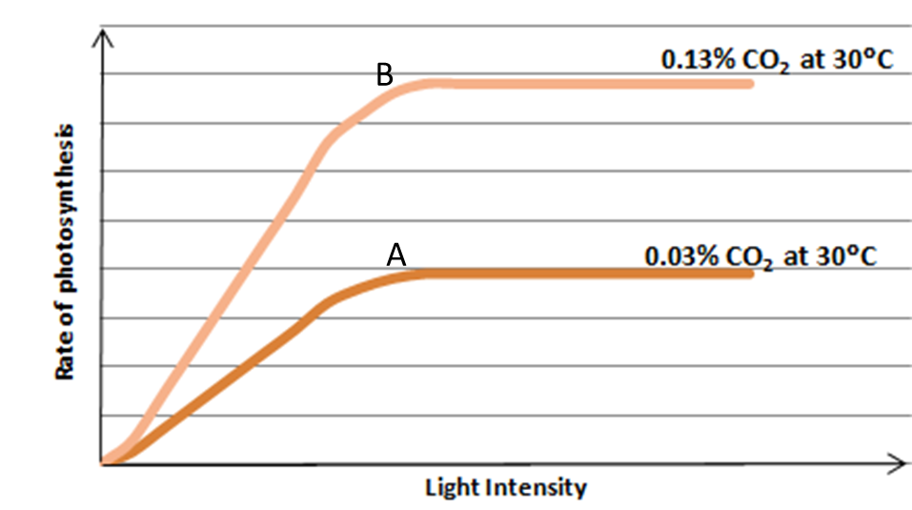

B. Plant structures and functions
- Name plant cells A, B and C and describe their structure and function.
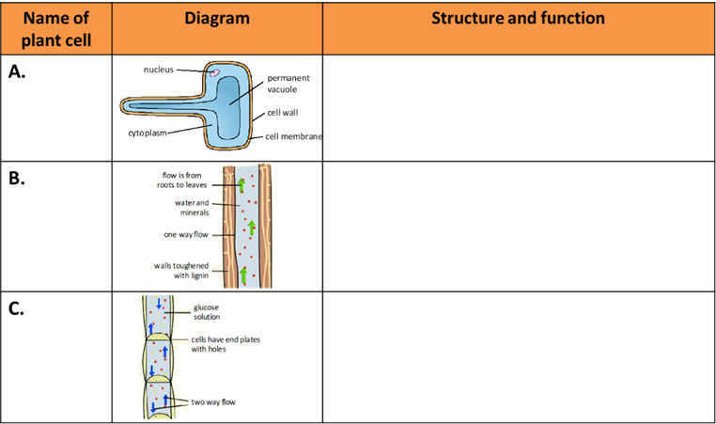

- What is the role of the root hair cell?
- How does the structure of the root hair cell help it carry out its job?
- Define ‘active transport’.
- Why does active transport need to occur in root hair cells?
- What vessel transports water and minerals around the plant?
- What vessel transports sucrose around the plant?
- Which vessel is made from dead cells?
- What is transpiration?
- What is a stoma?
- What factors increase the rate of transpiration?
- What factor reduces the rate of transpiration?
- Where does water vapour leave the plant by transpiration?
- What is a potometer?
- What is the benefit of needle shaped leaves to a cactus?
- What is translocation?
- A potometer was set up with a woody stem to estimate the rate of transpiration. An air bubble moved 30mm in 9 minutes. Estimate the rate of transpiration and show your working.

C. Plant structures and functions BIOLOGY ONLY
- What is the role of plant hormones?
- What is a positive tropism? Give an example of a positive tropism.
- What is a negative tropism? Give an example of a negative tropism.
- Where is auxin produced in the shoot?
- If a light is shining on the side of a shoot where will the auxin move to?
- What effect does auxin have on the cells in a shoot?
- Where is auxin produced in the root?
- What effect do auxins have on the cells in the roots?
- HT: How are gibberellins used in agriculture and horticulture?
- HT: How is ethene used in agriculture and horticulture?
- HT: How are auxins used in agriculture and horticulture?

